**THE UNIVERSITY OF BRITISH COLUMBIA**

FACULTY OF APPLIED SCIENCE, SCHOOL OF ENGINEERING

**Analysis of Sustainable Textile Supply Chain**

**Introduction**

Textile recycling is a form of recycling that focuses on collecting no longer wanted fabric, yarn or fiber and reprocessing them into useful products such as new clothes, fillings for pillows, furniture linings and much more. This helps reduce waste and demand for newly produced textile materials which are desirable as both consume energy which contribute to carbon emissions. Producing new textile material also uses farming space for plant-based materials and oil for petroleum-based fabrics which leads to clearing of forests for farming and oil extraction which damage habitats around oil fields.

**Supply chain**

The supply chain of recycled textiles involve 5 components in a structure shown in figure 1:

1. Collection centers collect unwanted textiles from potential donors.
2. Recycling facilities sort textiles collected by collection centers based on whether they could be used for new products. They also process usable textiles into raw material form.
3. Textile manufacturers use recycled raw material-form fabrics, yarns and fiber from recycling facilities to produce their products.
4. Retail distributors take products from textile producers and sell them to customers in the market.
5. Disposal sites take textiles deemed unusable from recycling facilities to be treated as waste.

The supply chain uses the push supply chain strategy which means supply chain components are required to fulfill the known demand from the market.

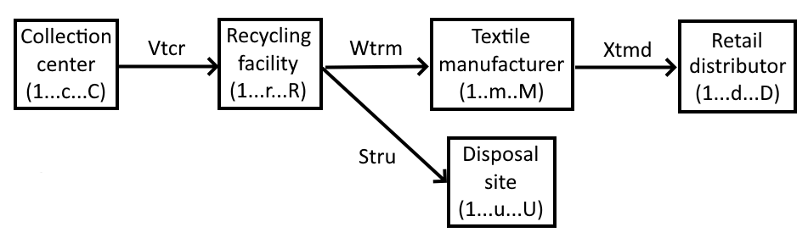

Figure 1: The recycled textile open-loop supply chain

**Optimization model design**

For our CPLEX analysis we have created a list of potential options to be part of our supply chain members. Factors that affect how well they suit our supply chain both positively and negatively are recorded and are considered by the CPLEX model. The data involved is listed below in Table 1-16. The aim for the analysis is to determine the optimal locations and capacities for textile collection centers, recycling facilities, textile manufacturers, disposal sites and retailers to balance economic efficiency and environmental impact in the form of carbon emissions.

**Data**

|  |  |
| --- | --- |
| Supply Chain Component | Quantity |
| Collection center | 4 |
| Recycling facilty | 3 |
| Textile manufacturer | 3 |
| Disposal site | 2 |
| Retail distributor | 5 |

Table 1: Quantity of supply chain component options

|  |  |
| --- | --- |
| Supply Chain Component | Setup cost ($) |
| Collection center | 5,000 |
| Recycling facilty | 20,000 |
| Textile manufacturer | 25,000 |
| Disposal site | N/A |
| Retail distributor | N/A |

Table 2: Setup cost of supply chain component options

|  |  |
| --- | --- |
| Collection center options | Collection cost ($/kg) |
| #1 | 40 |
| #2 | 55 |
| #3 | 60 |
| #4 | 75 |

Table 3: Collection cost of collection center options

|  |  |
| --- | --- |
| Recycling facility options | Sorting cost ($/kg) |
| #1 | 35 |
| #2 | 50 |
| #3 | 50 |

Table 4: Sorting cost of recycling facility options

|  |  |
| --- | --- |
| Recycling facility options | Processing cost ($/kg) |
| #1 | 90 |
| #2 | 100 |
| #3 | 110 |

Table 5: Processing cost of recycling facility options

|  |  |
| --- | --- |
| Textile manufacturer options | Manufacturing cost ($/kg) |
| #1 | 240 |
| #2 | 250 |
| #3 | 280 |

Table 6: Manufacturing cost of textile manufacturer options

|  |  |
| --- | --- |
| Disposal site options | Disposal cost ($/kg) |
| #1 | 10 |
| #2 | 15 |

Table 7: Disposal cost of disposal site options

|  |  |  |  |  |
| --- | --- | --- | --- | --- |
|  | Recycling facility options | | | |
| Collection center options |  | #1 | #2 | #3 |
| #1 | 3 | 5 | 15 |
| #2 | 4 | 2 | 17 |
| #3 | 7 | 6 | 7 |
| #4 | 10 | 12 | 4 |

Table 8: Distance in km between collection center and recycling facility options

|  |  |  |  |  |
| --- | --- | --- | --- | --- |
|  | Textile manufacturer options | | | |
| Recycling facility options |  | #1 | #2 | #3 |
| #1 | 2 | 3 | 4 |
| #2 | 3 | 2 | 3 |
| #3 | 4 | 2 | 1 |

Table 9: Distance in km between recycling facility and textile manufacturer options

|  |  |  |  |
| --- | --- | --- | --- |
|  | Disposal site options | | |
| Recycling facility options |  | #1 | #2 |
| #1 | 12 | 14 |
| #2 | 15 | 14 |
| #3 | 13 | 11 |

Table 10: Distance in km between recycling facility and disposal site options

|  |  |  |  |  |  |  |
| --- | --- | --- | --- | --- | --- | --- |
|  | Retail distributor | | | | | |
| Textile manufacturer options |  | #1 | #2 | #3 | #4 | #5 |
| #1 | 120 | 80 | 47 | 35 | 23 |
| #2 | 130 | 65 | 41 | 42 | 35 |
| #3 | 80 | 60 | 25 | 41 | 66 |

Table 11: Distance in km between textile manufacturer options and retail distributors

|  |  |
| --- | --- |
| Retail distributor | Demand (arbitrary units of product) |
| #1 | 10,000 |
| #2 | 7,000 |
| #3 | 5,000 |
| #4 | 3,000 |
| #5 | 2,000 |

Table 12: Demand of retail distributors

|  |  |
| --- | --- |
| Collection center options | Collection capacity (kg) |
| #1 | 18,000 |
| #2 | 10,500 |
| #3 | 13,000 |
| #4 | 20,000 |

Table 13: Collection capacity of collection center options

|  |  |
| --- | --- |
| Recycling facility options | Recycling capacity (kg) |
| #1 | 11,000 |
| #2 | 13,000 |
| #3 | 17,000 |

Table 14: Collection capacity of recycling facility options

|  |  |
| --- | --- |
| Textile manufacturer options | Manufacturing capacity (kg) |
| #1 | 12,000 |
| #2 | 16,500 |
| #3 | 19,000 |

Table 15: Collection capacity of textile manufacturer options

|  |  |
| --- | --- |
| Transportation cost ($/km) | 2 |
| Disposal rate of collected textiles | 10% |
| Truck capacity (kg) | 1000 |
| Truck carbon emissions (kg/km) | 0.35 |
| Monetary cost of carbon emissions ($/kg) | 10,000 |
| Weight of first objective | 0.75 |
| Weight of second objective | 0.25 |

Table 16: Independent variables relevant to the analysis

**Model**

**Sets:**

- *T*: Types of textiles (1 ... t ... T).

- *C*: Collection centers (1 ... c ... C).

- *R*: Recycling facilities (1 ... r ... R).

- *U*: Disposal sites (1 … u … U).

- *M*: Textile manufacturers (1 ... m ... M).

- *D*: Retail distributors (1 ... d ... D).

**Parameters:**

- *FCc*: Setup cost of collection center *c.*

- *FCr*: Setup cost of recycling facility *r*.

- *FCm*: Setup cost of textile manufacturer *m*.

- *PCtc*: Collection cost of textile *t* at center *c*.

- *PCAtr*: Sorting cost of collected textile *t* at facility *r*.

- *PCBtr*: Processing cost of recyclable textile *t* at facility *r*.

- *PCtm*: Manufacturing cost of recycled textile *t* at manufacturer *m*.

- *PCtu*: Disposal cost of textile *t* at site *u*.

- *Ecr*: Distance between collection center *c* and recycling facility *r*.

- *Erm*: Distance between recycling facility *r* and manufacturer *m*.

- *Eru*: Distance between recycling facility *r* and disposal site *u*.

- *Emd*: Distance between manufacturer *m* and distributor *d*.

- *Dtd*: Demand for textile *t* at distributor *d*.

- *CCtc*: Maximum collected amount of textile *t* at center *c*.

- *CCtr*: Recycling capacity for textile *t* at facility *r*.

- *CCtm*: Manufacturing capacity for textile *t* at manufacturer *m*.

- *Nt*: transportation cost per km associated with textile *t*

- *et*: Disposal rate of textile *t*.

- *gt*: Truck capacity for textile t.

- *h*: Truck carbon emissions per km.

- *CE*: Carbon emissions’ monetary value per kg of emission.

- *WE1*: Weight of the first objective.

- *WE2*: Weight of the first objective.

**Decision Variables:**

- *Vtcr*: Amount of textile *t* transported from collection center *c* to recycling facility *r*.

- *Wtrm* : Amount of textile *t* transported from recycling facility *r* to manufacturer *m*.

- *Stru* : Amount of textile *t* transported from recycling facility *r* to disposal site *u*.

- *Xtmd*: Amount of textile *t* transported from manufacturer *m* to distributor *d*.

- *Yc*: Binary variable; 1 if collection center *c* is utilized, 0 otherwise.

- *Zr*: Binary variable; 1 if recycling facility *r* is utilized, 0 otherwise.

- *Am*: Binary variable; 1 if manufacturer *m* is utilized, 0 otherwise.

**Objective Variables:**

- *Z1*: Objective function for the first objective

- *Z2*: Objective function for the second objective

**Objective function and constraints:**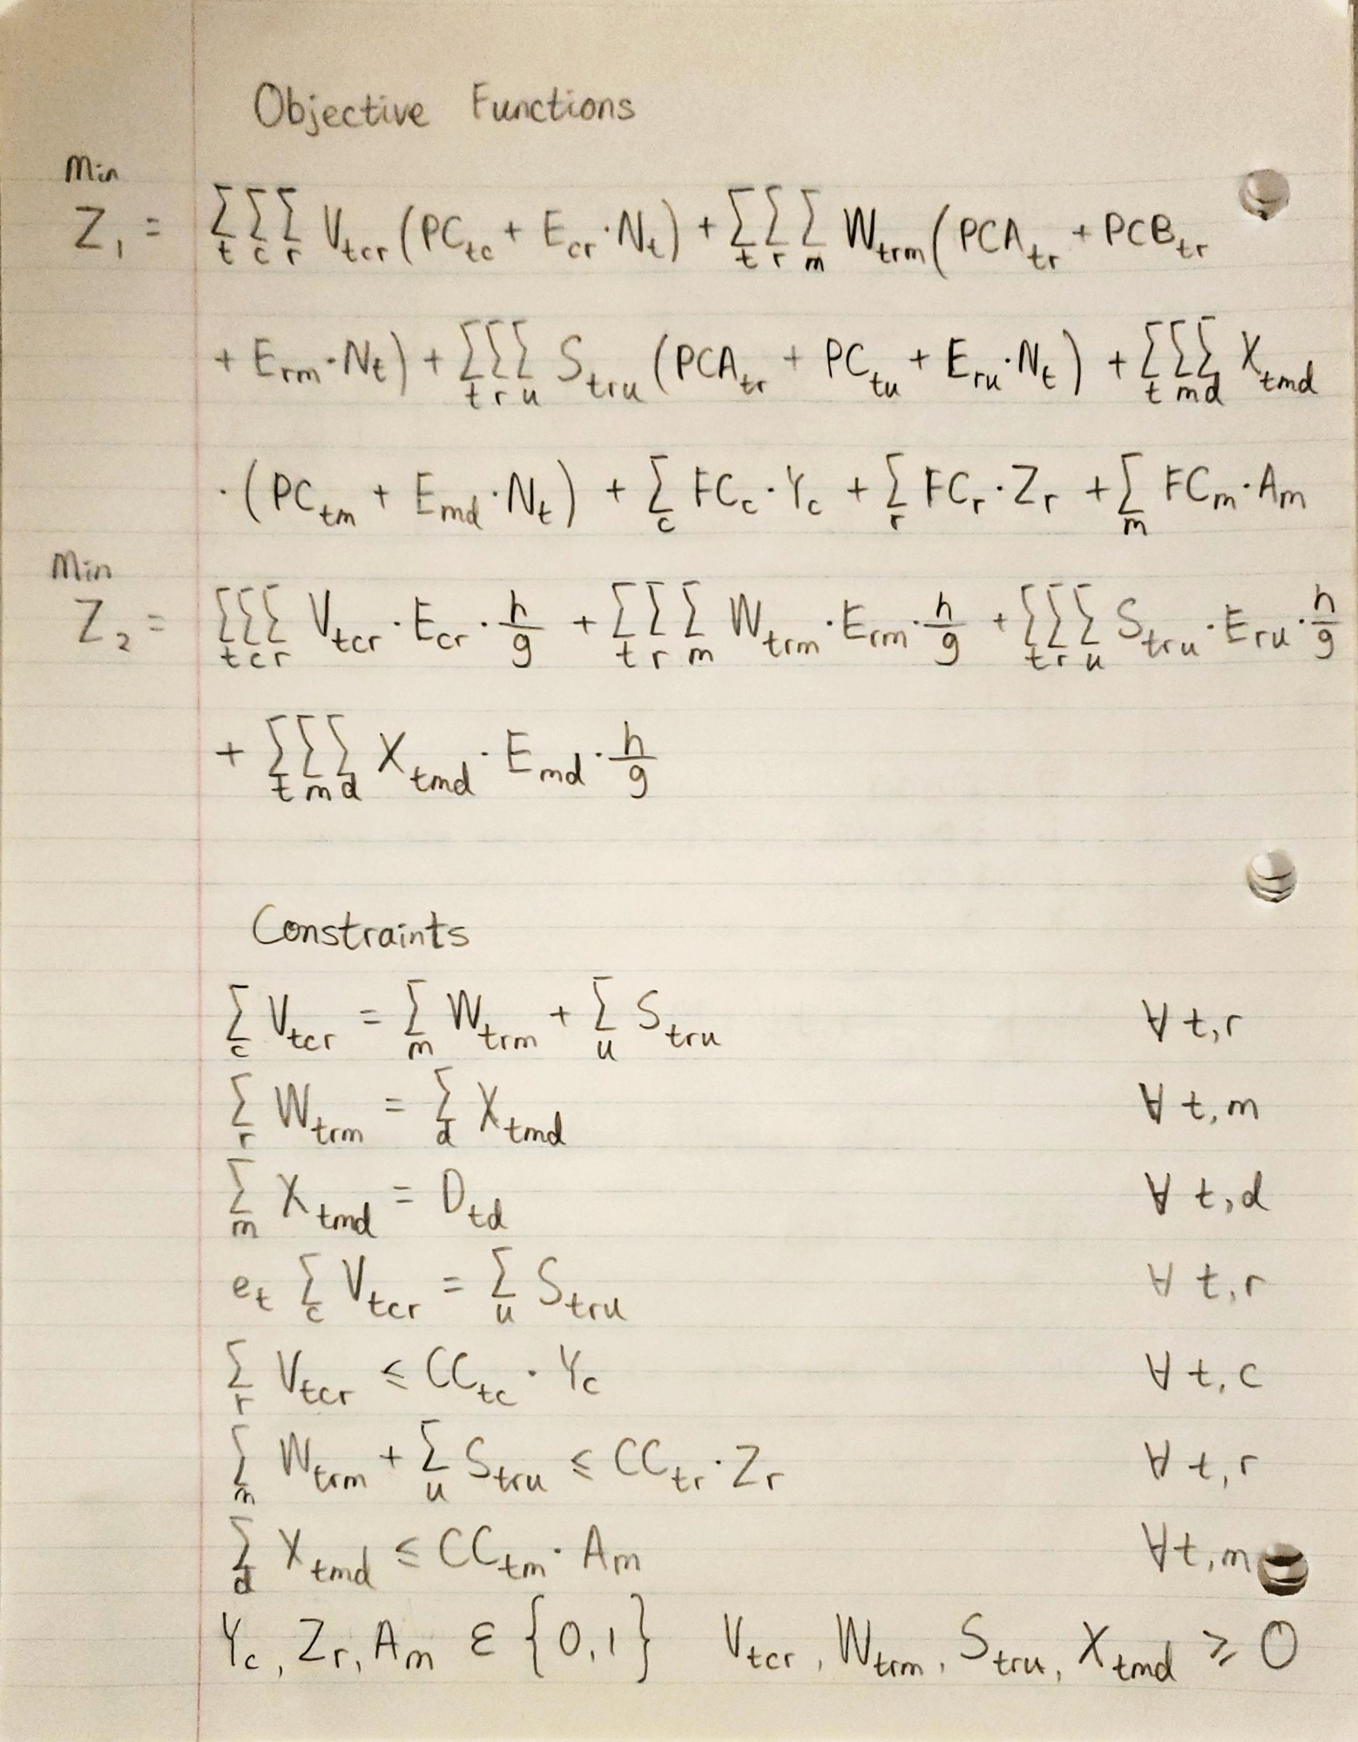

Figure 2: Objective functions and constraints of the model

Figure 2 shows the objective functions and constraints involved in the project. Objective function Z1 focuses on minimizing the cost of setting up and running the supply chain while objective function Z2 focuses on minimizing the carbon emissions from transportation using trucks.

The mathematical model involves 9 constraints. Constraints #1 and #2 ensures there is no loss of textiles in between supply chain components. Constraint #3 specifies that the amount of textiles received by retail distributors matches the market demand for the same distributor. Constraint #4 controls the amount of disposed textile to be a portion of all collected textiles based on the decided disposal rate. Constraint #5, #6 and #7 makes sure the collection centers, recycling facilities and textile manufacturers do not exceed their production capacities. Constraint #8 is a binary constraint. Constraint #9 ensures all decision variables that are not binary are non-negative.

**Result analysis**

IBM ILOG CPLEX 22.1.1 was used to solve this model which has 26 constraints, 42 non-zero variables, 10 binary variables and 232 non-zero coefficients.

Based on our data, the optimal supply network will run according to the diagram shown in figure 3 to minimize the total operating cost while fulfilling demands.

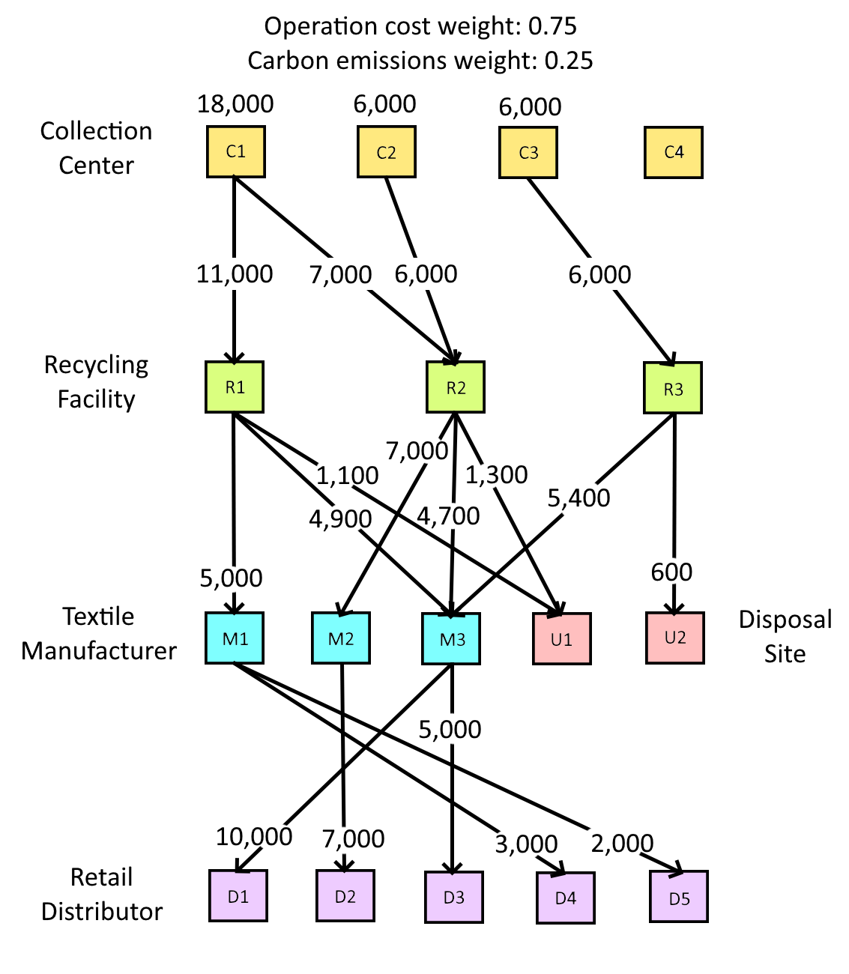

Figure 3: Optimal textile recycling supply network diagram

If we focus on reducing environmental pollution more by decreasing the weighting of Z1 and increasing that of Z2, we can see a shift in the collection centers chosen and flow of textiles in the diagram shown in figure 4 to reflect this change of focus.

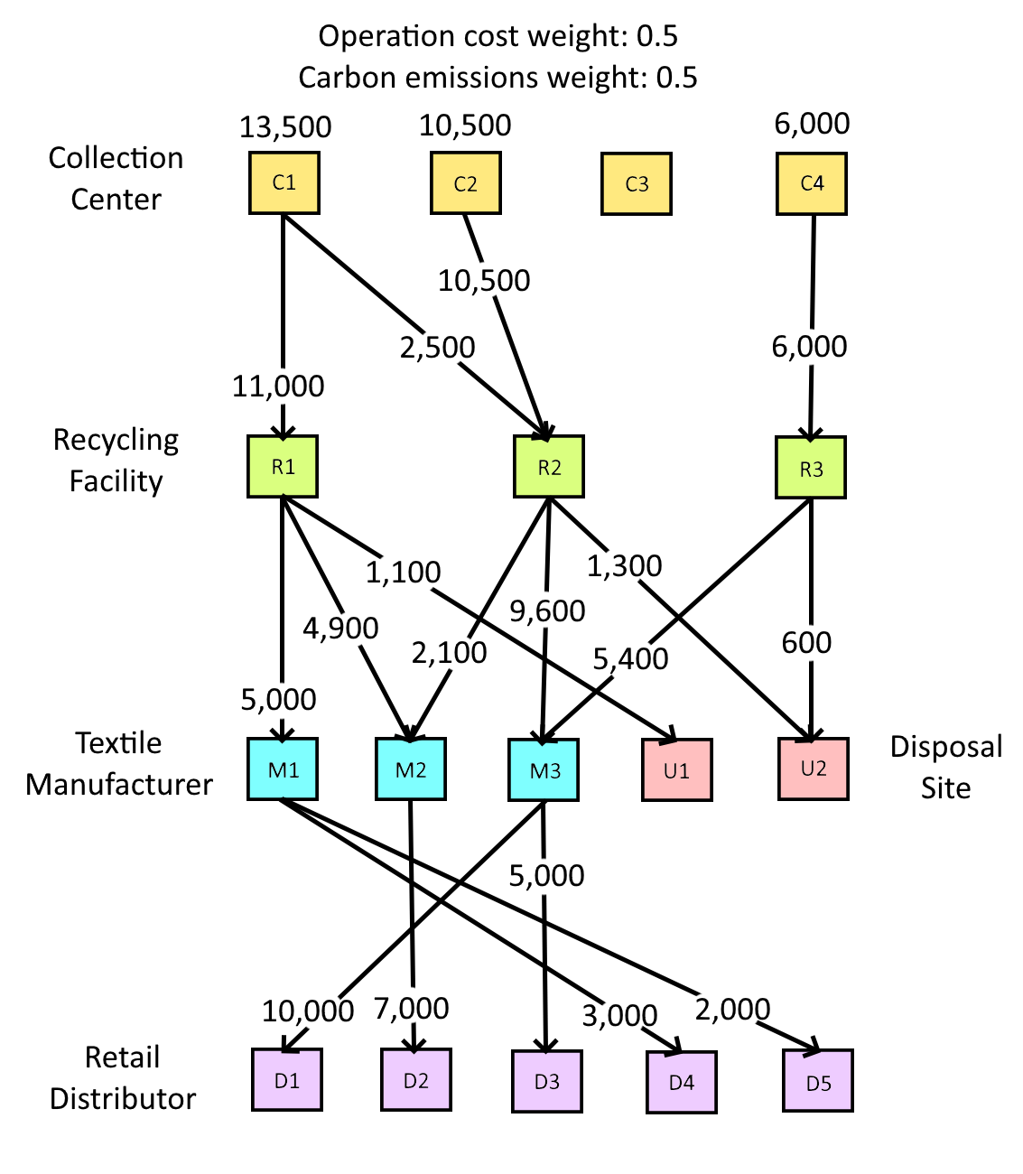

Figure 4: Optimal textile recycling supply network diagram with altered weighting

**Conclusion**

In conclusion, the objective of this study was to address the complexities inherent in a textile recycling supply chain network, with the primary focus of developing the most efficient solution utilizing IBM ILOG CPLEX 22.1.1. Furthermore, our focus extended to refining the spatial layouts and capacities of pivotal elements within the supply chain, spanning collection centers, recycling facilities, textile manufacturers, disposal sites, and retailers. To ensure feasibility and validity of the results, 9 constraints were used, including no loss of textiles between supply chain members, and the assurance that specific supply chain members do not exceed their production capacities.

Moreover, the sensitivity analysis reveals the adaptability of the supply chain to varying environmental priorities. By adjusting the weights assigned to the two objectives, the model can respond to a shift in focus towards environmental sustainability. This is demonstrated by the altered supply network configuration when environmental concerns take precedence, resulting in a redistribution of collection centers and textile flow.

In essence, the findings underscore the importance of adopting a holistic approach to textile recycling supply chain management. The proposed model provides a robust framework for decision-makers to optimize operations, considering both economic and environmental factors. As the textile industry continues to grapple with sustainability challenges, the insights from this study offer actionable strategies to foster a circular economy, reduce waste, and mitigate the ecological footprint of textile production and disposal.

**Appendix**  
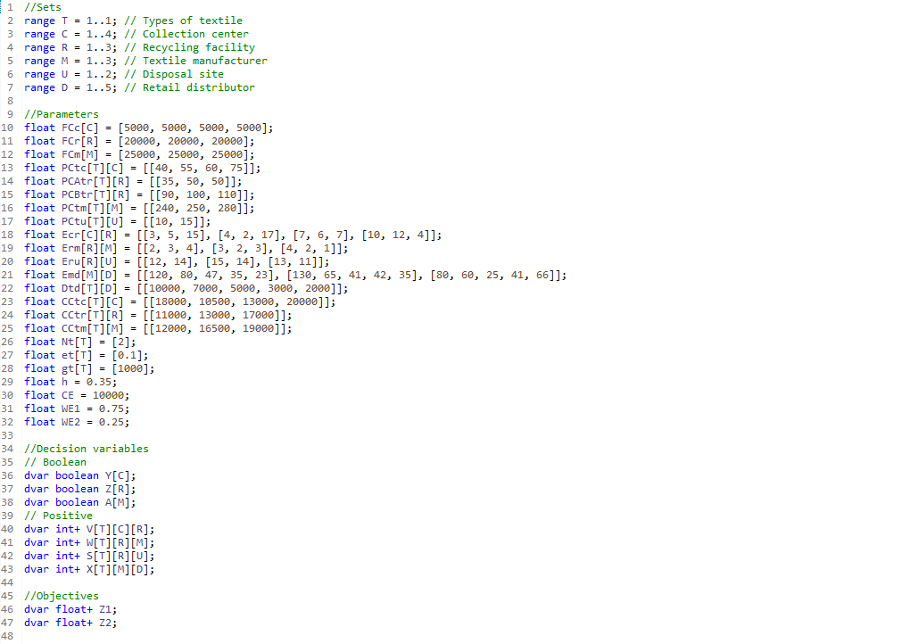  
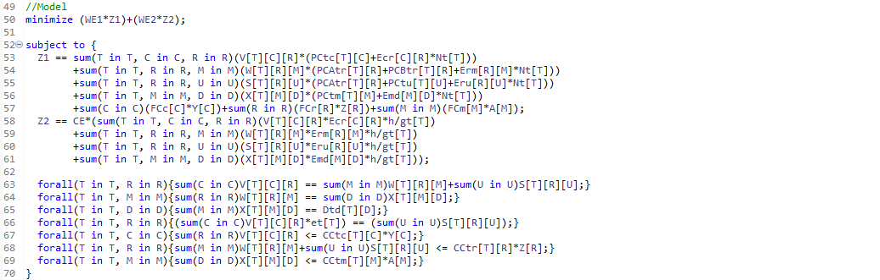  
Figure A1: CPLEX Code

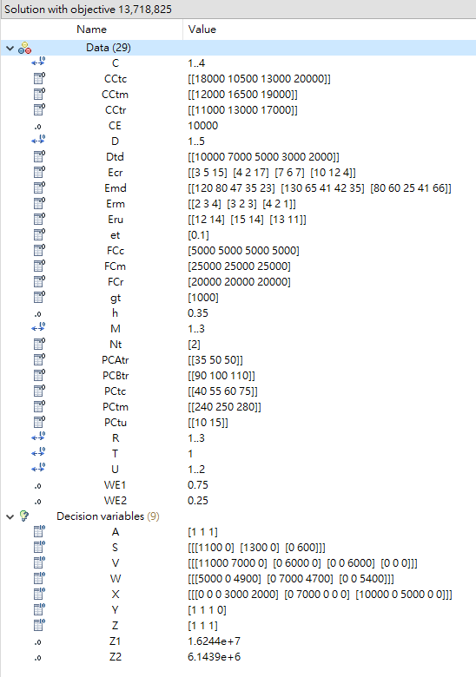

Figure A2: Results of optimization problem with default weightings

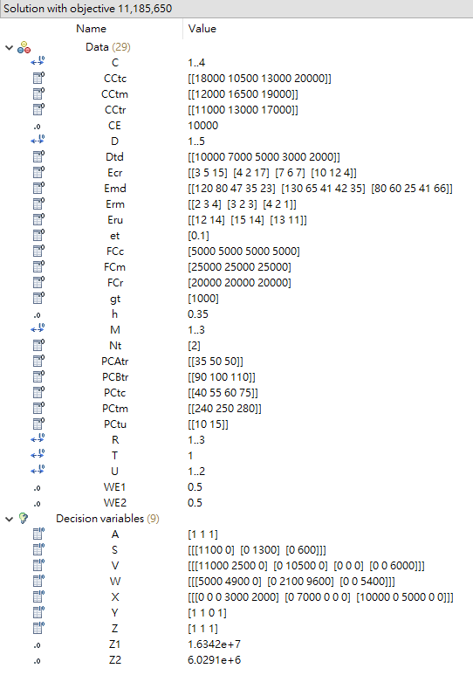

Figure A3: Results of optimization problem with changed weightings